Title

**Angus Retallack1, Sami Rifai1, Graeme Finlayson1,2, Bertram Ostendorf1, Megan Lewis1**

1Department of Ecology and Evolutionary Biology, The University of Adelaide, South Australia

2 Bush Heritage Australia, PO Box 329, Flinders Lane, Melbourne, Victoria, 8009, Australia

**Correspondence**

Angus Retallack

Department of Ecology and Evolutionary Biology, The University of Adelaide, North Terrace Campus, Adelaide, South Australia, 5005, Australia

E-mail: [angus.retallack@adelaide.edu.au](mailto:angus.retallack@adelaide.edu.au)

**Abstract**

**Keywords**

# Introduction

The Australian arid rangelands encompass a variety of environmentally and economically significant ecosystems covering vast areas of the country's land area. These lands are important to a number of stakeholders, including aboriginal communities, environmental conservation groups and pastoralists. The value of the land is therefore interpreted from different perspectives, holding cultural significance, biodiversity conservation value and economic value from stock grazing. Cooperation between these stakeholders is required for land management to be achieved in the most effective manner, and understanding the variables that influence change in these areas is essential in achieving good management. Management groups focussed on both ecological conservation and pastoral productivity rely on the same fundamental resource, the vegetation that exists in these arid ecosystems. However, management actions differ due to a difference in the final goal of management. While land management for maximising pastoral productivity would traditionally be focussed on maximising pastoral productivity to increase economic returns, conservation managers are more strongly focussed on the ecological health and biodiversity of vegetation communities. Understanding the influences of different management regimes on the change in vegetation cover over time is necessary to reach a balance between maintaining economic benefits essential for the Australian economy and regional communities while maintaining important biodiversity assets, the benefits of which are easily overlooked in contrast with easily-recorded monetary transactions.

[section on impacts of overgrazing in Chenopod shrublands]

[expected timescale of recovery]

[identifying a small signal in a LOT of (precip) noise]

While it is widely known that vegetation in such ecosystems exhibit strong responses to climatic variables such as rainfall, knowledge as to the effects of different land management is less known and more difficult to assess. Satellite-based sensors such as MODIS serve as a useful tool for assessing changes across the vast spatial scale of the arid rangelands using products such as spectrally-unmixed fractional vegetation cover (Guerschman, 2020).

# Materials and methods

## Study areas and structure

This study comprises three main analytical components, all focussed on areas of the South Australian arid rangelands and spanning around 21 years, from 2001 to half way through 2021 (based on the availability of the MODIS fractional cover dataset used). This research is conducted in collaboration with the non-profit organisation Bush Heritage Australia (BHA), and is hence focussed on the broader region surrounding one of their two south Australian reserves, Bon Bon Station Reserve, which has been destocked since 2008. BHA manage properties around Australia for the purpose of protecting and restoring unique ecological systems.

Environmental / vegetation info

The first analytical component comprises of a narrow study region defined by a 10 km buffer around Bon Bon (Figure 1). For statistical purposes, this buffer distance results in a total study area roughly twice the size of Bon Bon itself, leading to a balance in control and experimental land area. This analysis investigates the effect of destocking on fractional vegetation cover using the conservation efforts of Bush Heritage Australia (BHA) as a case study.

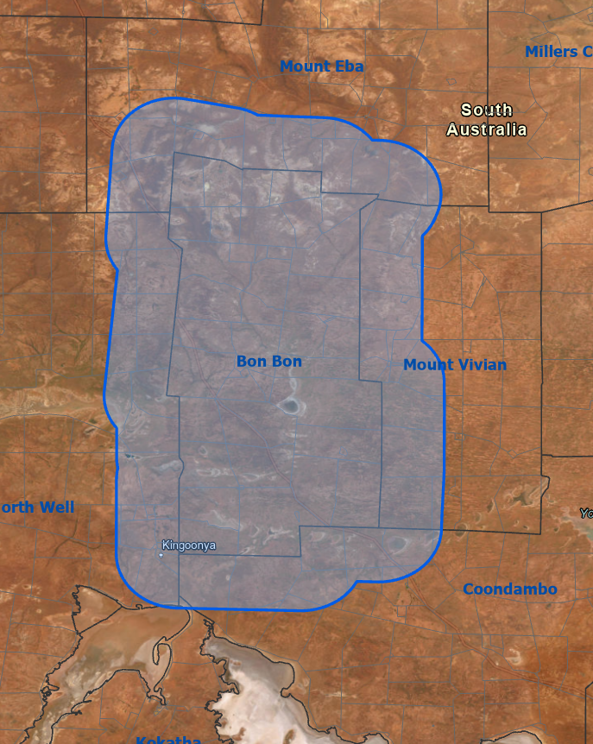

Figure 1.

The second study region area encompasses the BHP-operated leases of Andamooka, Mulgaria, Purple Downs, Roxby Downs and Stuart Creek (Figure 2). As we have access to precise stocking rates over the study period for these stations, this analysis will evaluate the effect of stocking intensity on fractional vegetation cover.

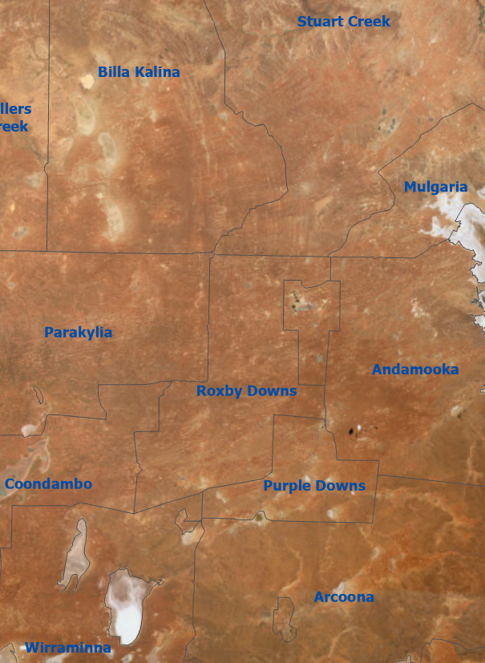

Figure 2.

Finally, a broad-scale study focusses on a 9 million hectare region of the South Australian arid rangelands, centred around Bon Bon Station Reserve (Figure 3). This study area was selected based on the extent of the three Interim Biogeographic Regionalisation for Australia (IBRA) subregions that Bon Bon is situated in – The Breakaways, Roxby and Kingoonya. The Breakaways region is not spatially contiguous, also existing far to the north. This northern segment of the bioregion is excluded.

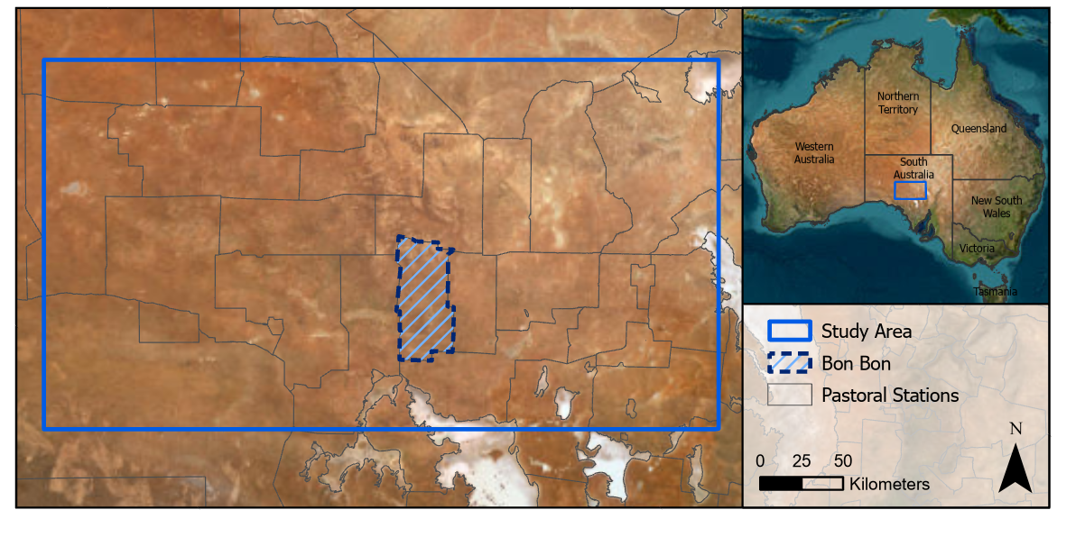

Figure 3.

## Input datasets and processing

Table 1 summarises the datasets used in this study. All datasets were resampled to match the ground sampling distance (GSD) of the MODIS fractional cover dataset (500 m) and projected to the GDA94 MGA Zone 53 coordinate system. Vector datasets such as property boundaries were converted to raster.

Table 1. Datasets used for statistical analysis

|  |  |  |
| --- | --- | --- |
| **Dataset** | **Name** | **Source** |
| Fractional vegetation cover | Fractional Cover - MODIS, CSIRO algorithm. Version 1.0. | (Guerschman, 2020) |
| Rainfall | GPM IMERG Final Precipitation L3 1 month 0.1 degree x 0.1 degree V06 (GPM_3IMERGM) | (Huffman et al., 2019) |
| Vegetation type | National Vegetation Information System (NVIS) Major Vegetation Subgroups (Version 6.0) | (Australian Government Department of Climate Change, Energy, the Environment and Water, 2020) |
| Stocking data |  | Provided confidentially from pastoral lease holders |

Table 2. Supplementary datasets (Used for masking, clipping, etc.)

|  |  |  |
| --- | --- | --- |
| **Dataset** | **Name** | **Source** |
| Water Areas | Surface Hydrology Polygons (Regional) | (Crossman and Li, 2015) |
| Station Boundaries | Pastoral Stations - ARC | (SA Department of Environment, Water and Natural Resources, 2015) |
| IBRA subregions |  |  |

The MODIS monthly fractional cover product is used as the variable of interest for in our analyses (Guerschman, 2020) and includes fractional percentages of photosynthetic, non-photosynthetic and bare cover with a 500 m GSD.

The Integrated Multi-satellitE Retrievals for GPM (IMERG) modelled precipitation dataset was used for rainfall data. In preliminary testing three different rainfall datasets were used, all providing similar results. The IMERG dataset was chosen to be used based on the large distance between rainfall stations in the study area bringing question to the accuracy of interpolated datasets such as the Australian Gridded Climate Data precipitation AGCD. Additionally, Islam et al. (2020) found IMERG to be the most accurate available precipitation product for Australia, using the Scientific Information for Land Owners (SILO) interpolated rainfall dataset as reference. All of the rainfall datasets tested, including IMERG, were found to positively bias rainfall values in arid regions compared to the reference dataset (Islam et al., 2020). The data was processed into 3 and 12 month rolling sum composites to capture lagged responses of vegetation to rainfall.

National Vegetation Information System (NVIS) vegetation type mapping data was included in modelling, particularly to address differing responses of different vegetation communities to rainfall.

Stocking information was collected from a variety of sources. In south Australia, reported stocking rates are not publicly accessible, and require permission from individual pastoral lease holders to be granted data access. For The narrow scale analysis, a “time since destock” variable was produced, which is a numeric variable increasing continuously from the destock year. Bon Bon is known to have been destocked from 2009, while local knowledge of surrounding properties and discussion with lease holders allowed us to make a confident assumption that the properties surrounding Bon Bon were not destocked for any significant period throughout the study period. The Broken Hill Proprietary (BHP) mining company supplied detailed annual stocking data for the pastoral stations surrounding the Olympic Dam mine, situated north of Roxby Downs in central South Australia. This information was provided confidentially, and hence a source is not publicly available. Stock numbers were divided by the total area of their respective pastoral leases to give an indication of stock density. In reality, stock are moved between paddocks within a lease, and paddocks will have their own stocking rates that vary over time. However, paddock specific data was not available to us, so stock numbers at a lease wide scale were used.

All datasets were masked based on several parameters to exclude locations that would provide unreliable data, or that were not relevant to the study question. Water areas were excluded using the … dataset from Geoscience Australia (<https://ecat.ga.gov.au/geonetwork/srv/api/records/12777e32-ec4f-055a-e053-10a3070a2ce2>), as well as by excluding pastoral leases that were strongly associated with water features such as the Kati Thanda-Lake Eyre National Park, Lake Torrens National Park, and various salt lakes. Several National Vegetation Information System (NVIS) groups associated with aquatic or highly unproductive vegetation systems were also excluded, i.e. inland aquatic freshwater, lagoons, and naturally bare areas. Vegetation systems with very low representation across the study area were also removed as sample sizes were very small and responses are not representative of the larger study area of interest. Pastoral leases associated with regional centres or mines were also removed, including the Olympic Dam mine site and Cooper Pedy. All pixels within a 500 m buffer of all pastoral lease boundaries were also removed, as the management regime of fence-line pixels is ambiguous.

## Analytical approaches

**Spatial generalised additive modelling (GAM)**

**We fith generalized additive models (GAMs) with a spatial varying offset term** for the two narrow scale analyses. The “mgcv” (source) package for the R programming language was used for model creation, while mgcViz (source), gratia (source), and ggplot2 were used for plotting results. Models for both analyses followed the same structure, with model parameters being set as below:

Vegetation cover fraction ~

Management variable +

s(date, bs = “ts”) +

s(month, bs = “cc”) +

precipitation (3 month total) * NVIS group +

precipitation (12 month total) * NVIS group.

The GAMs were fit using the "fREML" (fast Restricted Maximum Likelihood) method. The date term used a shrinkage version of a thin plate regression spline to reduce overfitting, and the month term used a cubic cyclic term to ensure continuity between December - January. Management variable was modeled as a binary term, and precipitation (3 or 12 month) was modeled as a linear function with interactions conditional on the underlying NVIS major vegetation group.

For each study area, a separate model was created for each of the different cover types. In the study area surrounding Bon Bon, time since destock was used as the management variable. For the pastoral leases operated by BHP, stocking intensities were used as the management variable.

**Model validation**

## Effect of stocking intensity

Spatial GAM. Relationship between stocking rates and vegetation cover at stations that have not been destocked for a significant period. Informs of a general relationship between stocking intensity and vegetation cover

## Broad-scale drivers of change in fractional vegetation cover

Anomaly-based linear regression.

The effect sizes isolated by the GAMs are too complex to make confident conclusions. No stocking data included. Differences between how vegetation cover changes over time compared between stations can be interpreted based on knowledge of the management at different sites. I.e. Bon Bon, managed for conservation – is there evidence that vegetation cover has improved favourably compared to neighbouring properties where a destock has not occurred.

# Results

## Effect of destocking on fractional vegetation cover

Partial effect plots of variables included in GAMs. Effect of time since destock

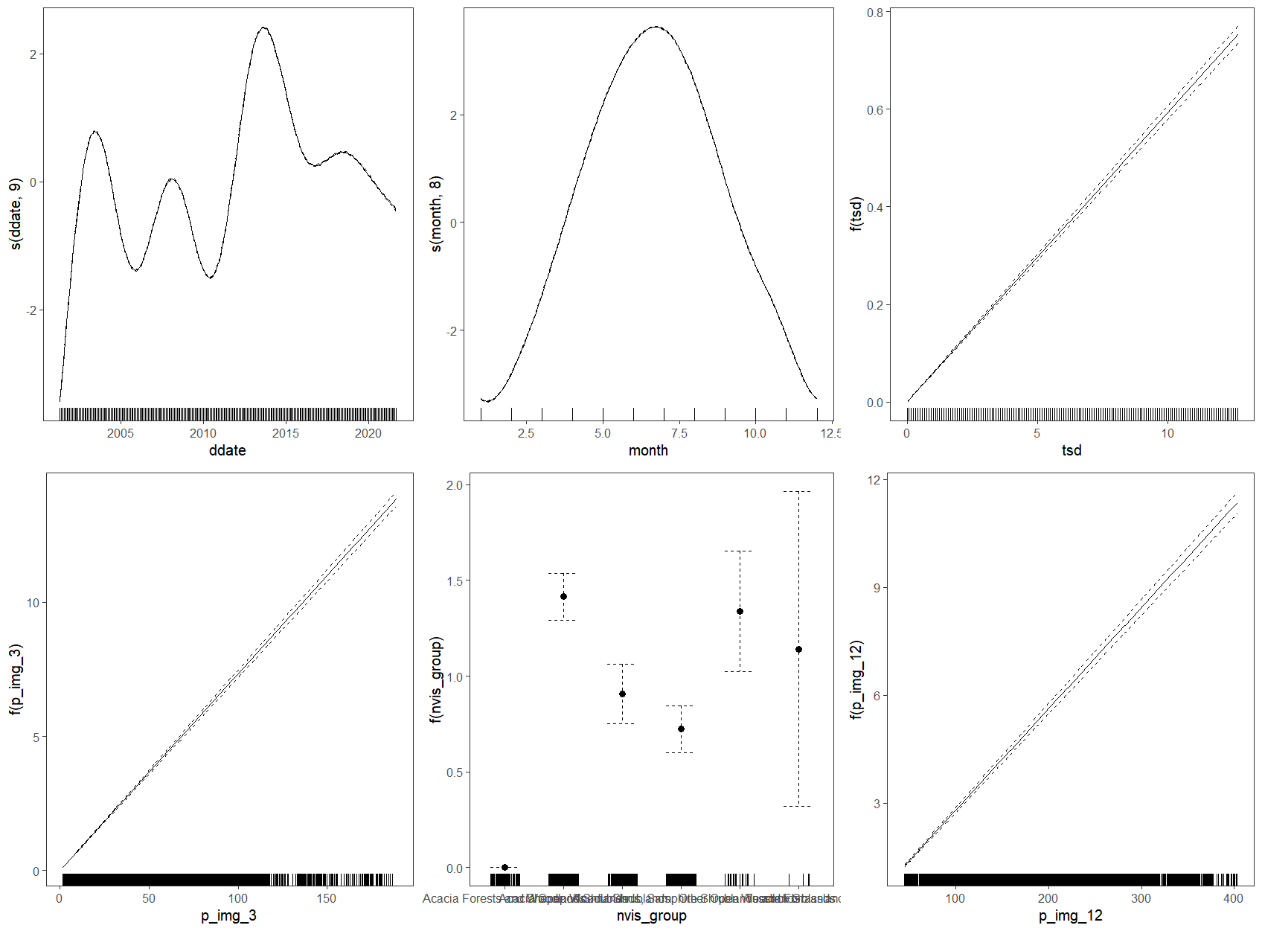

## Effect of stocking intensity on fractional vegetation cover

In operational pastoral leases, how does changing stocking intensity over time relate to changes in vegetation cover.

Partial effect plots of variables included in GAMs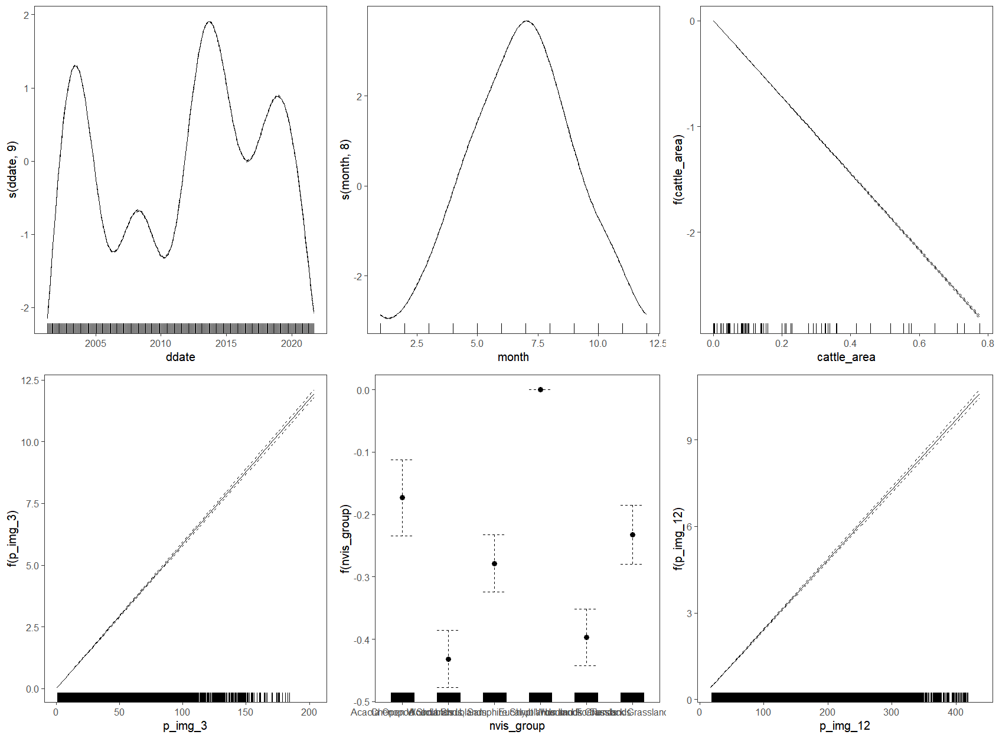

## Broad-scale drivers of change in fractional vegetation cover

Vegetation cover anomaly over time plots – comparisons between nearby stations. Are differences between station explainable by differing management?

Bon Bon and surrounding

Yellabinna RR and surrounding

Arid Recovery and surrounding

# Discussion

**Effect of destocking on fractional** **vegetation cover**

Effects of destock / conversion of a historically pastoral property to conservation

**Effect of stocking intensity on fractional** **vegetation cover**

Effect of stocking rate

**Broad-scale drivers of change in fractional** **vegetation cover**

General differences between change sin

# Conclusion

# Acknowledgements

We acknowledge Bush Heritage Australia staff and supporters for supporting this project. This project is being partially supported by the Thyne Reid Foundation. We acknowledge BHP for kindly providing stocking data used in the analysis.

The authors declare no conflicts of interest.

# References

Australian Government Department of Climate Change, Energy, the Environment and Water, 2020. National Vegetation Information System V6.0.

Crossman, S., Li, O., 2015. Surface Hydrology Polygons (Regional).

Guerschman, J., 2020. Fractional Cover - MODIS, CSIRO algorithm. Version 1.0.

Huffman, G.G., Bolvin, D.T., Braithwaite, D., Hsu, K., Joyce, R., Kidd, C., Nelkin, E.J., Sorooshian, S., Tan, J., Xie, P., 2019. GPM IMERG final precipitation L3 1 month 0.1 degree x 0.1 degree V06.

Islam, Md.A., Yu, B., Cartwright, N., 2020. Assessment and comparison of five satellite precipitation products in Australia. Journal of Hydrology 590, 125474. https://doi.org/10.1016/j.jhydrol.2020.125474

SA Department of Environment, Water and Natural Resources, 2015. Pastoral Stations - ARC. Bioregional Assessment Source Dataset.